**Session 4 - MapReduce Assignments**

1. Anagram

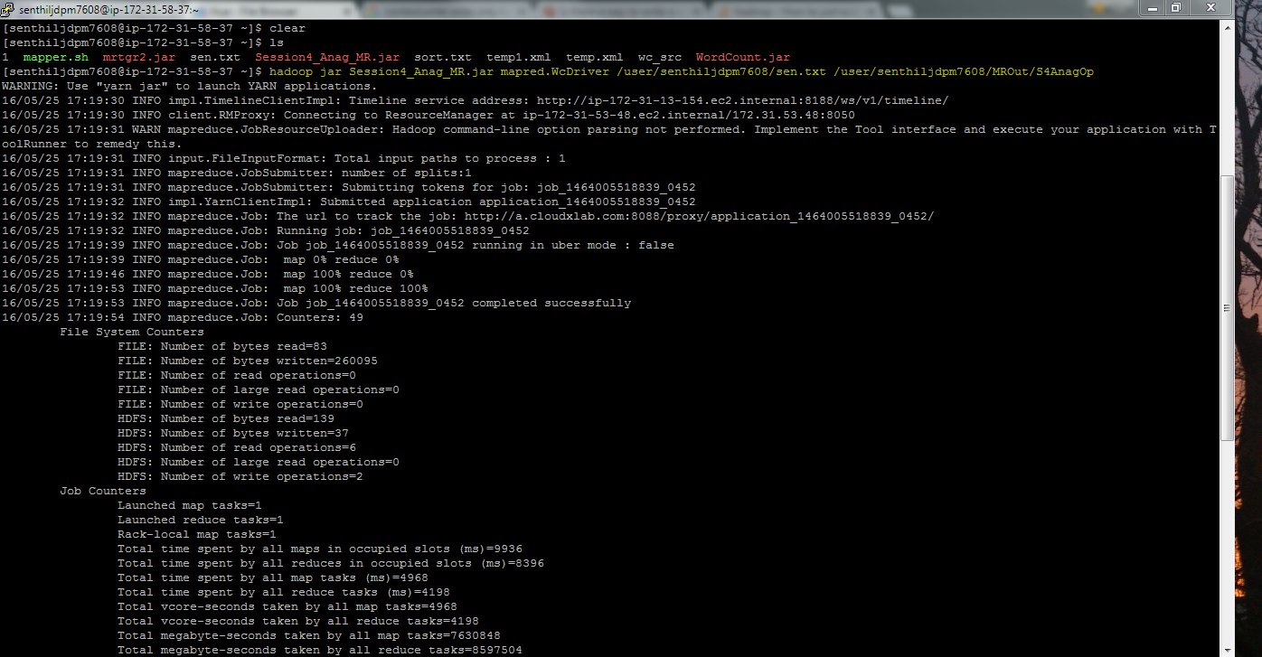

Output:

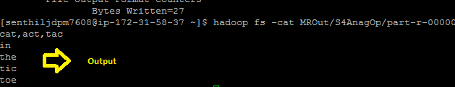

Jar file:



1. DNA 3a

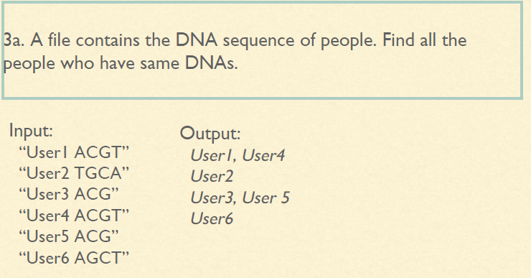

Solution:

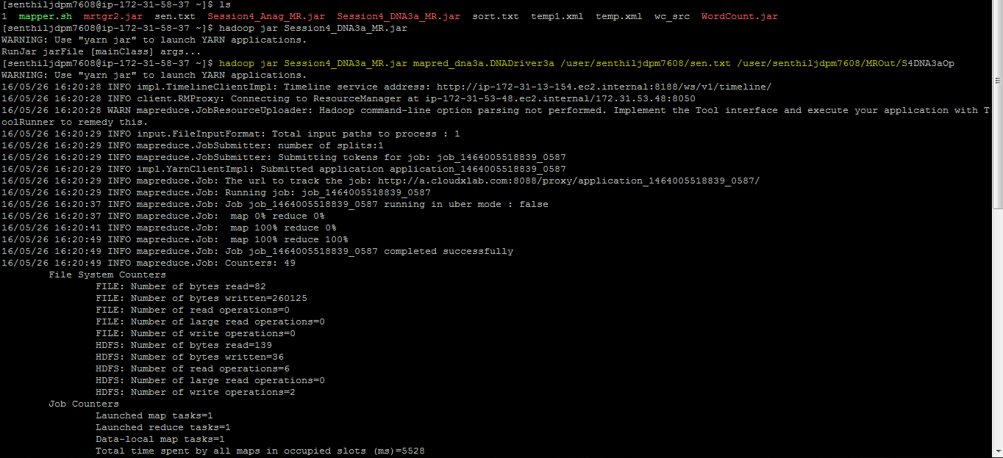

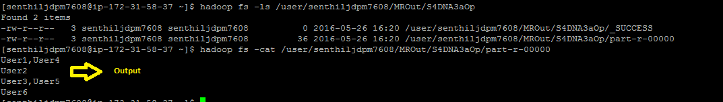

Jar file:



1. DNA 3b

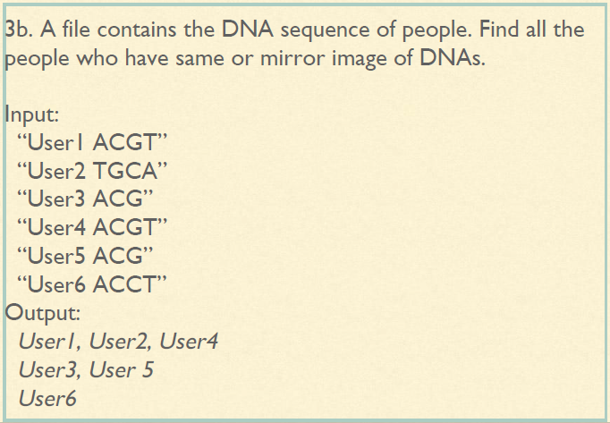

Solution:

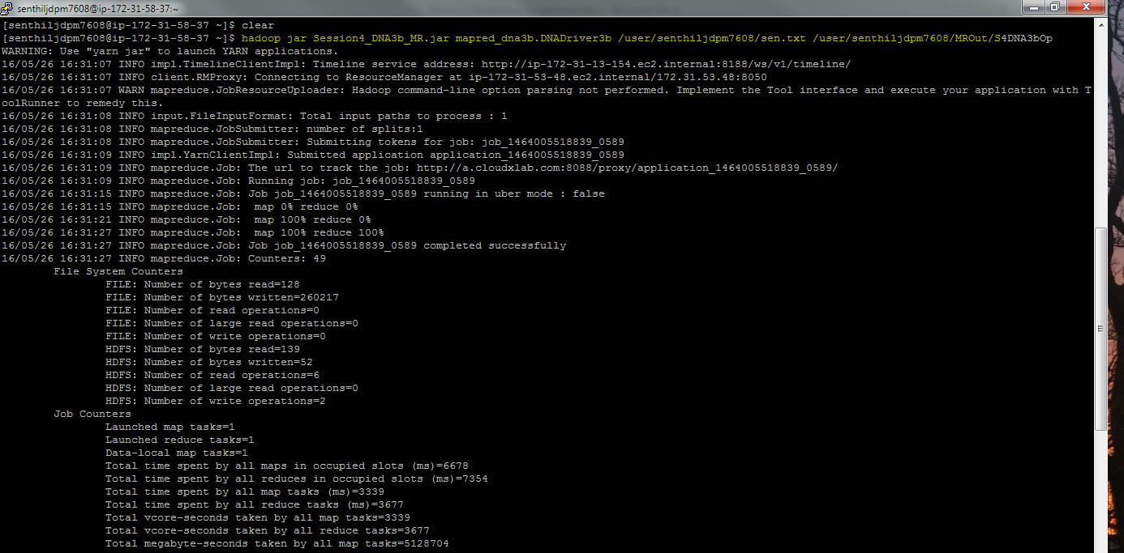



Jar file:

